**Experiment No: 05**

**Experiment name:**

(i) A program to traverse of a linked list.

(ii) ) A program to search an element of a linked list.

(iii) ) A program to insert last with searching of a linked list.

**Objectives:**

To study,write program and check its result to traverse, searching and inserting last an element in a linked list.

**Pseudo code 1:**

|  |  |
| --- | --- |
| #include<stdio.h>  struct student  {  int value;  struct student *next;  };  int main()  {  struct student s1,s2,s3,*head,*ptr;  s1.value=10;  s1.next=&s2;  s2.value=20;  s2.next=&s3; | s3.value=30;  s3.next=NULL;  head=&s1;  ptr=head;  while(ptr!=NULL)  {  printf("%d\n",ptr->value);  ptr=ptr->next;  }  return 0;  } |

**Result 1:**

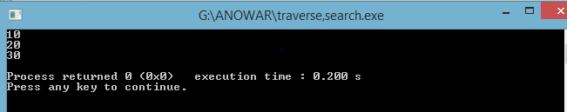

**Pseudo code 2:**

|  |  |
| --- | --- |
| #include<stdio.h>  struct student  {  int value;  struct student *next;  };  int main()  {  struct student s1,s2,s3,*head,*ptr;  s1.value=10;  s1.next=&s2;  s2.value=20;  s2.next=&s3;  s3.value=30;  s3.next=NULL;  head=&s1;  ptr=head;  int v,found; | printf("Enter your search value\n");  scanf("%d",&v);  while(ptr!=NULL)  {  if(ptr->value==v)  {  found=1;  }  ptr=ptr->next;  }  if(found==1)  {  printf("value found\n");  }  else  {  printf("Value Not found\n");  }  return 0;  } |

Result 2:

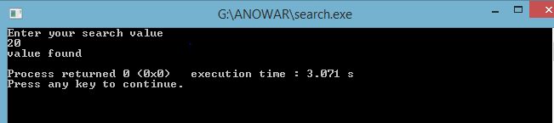

**Pseudo code 3:**

|  |  |
| --- | --- |
| #include<stdio.h>  struct student  {  int value;  struct student *next;  };  typedef struct student node;  node *p,*q,*h;  int main()  {  int x;  h=0,q=0;  for(;;)  {  printf("-99 to break\n");  scanf("%d",&x);  if(x==-99)  break;  p=(node*)malloc(sizeof(node));  if(h==0)  {  p->value=x;  p->next=NULL;  h=p;  q=p;  }  else  {  p->value=x;  p->next=NULL;  q->next=p;  q=p;  } | }  p=h;  printf("The insert value is:\n");  while(p!=NULL)  {  printf("%d\n",p->value);  p=p->next;  }  //search  int v,found;  p=h;  printf("Please Enter Your Search Value\n");  scanf("%d",&v);  while(p!=NULL&&found!=1)  {  if(p->value==v)  {  found=1;  }  p=p->next;  }  if(found==1)  {  printf("value found\n");  }  else  {  printf("Value Not found\n");  }  return 0;  } |

**Result 3:**

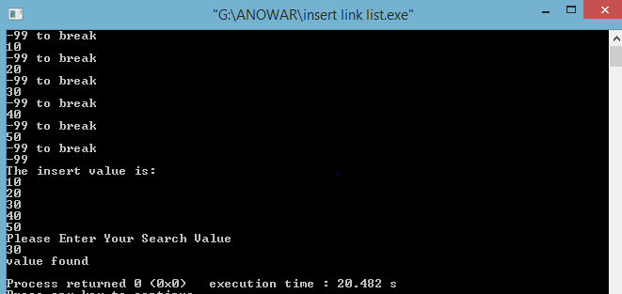

**Discussion:**

From study about traverse, search, insert element in a linked list ,i will know how can I do it .First I write an algorithm ,then I write those program according to it.In traverse , I traverse a linked list by getting some element. In search, I found out a search value that is already fixed. In Insert, I can insert infinite element by a linked list and there I can search any element. Then I can successfully done it.